***Experiment 10***

**Aim:** Data Sampling and Stratification: Implement data sampling techniques to generate representative subsets of large datasets, and stratify the data based on specific criteria for balanced sampling.

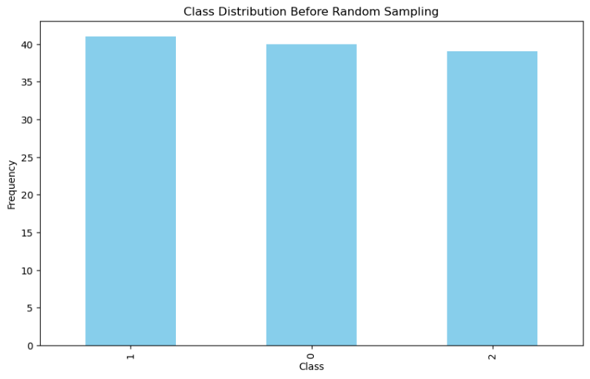***Dataset Sampling and Visualization:***

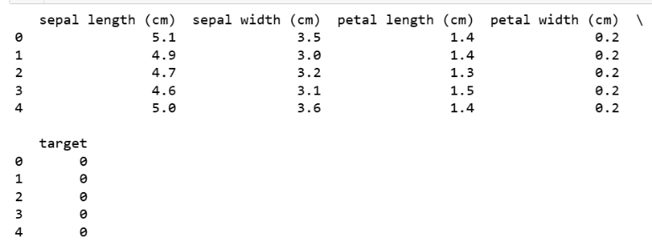

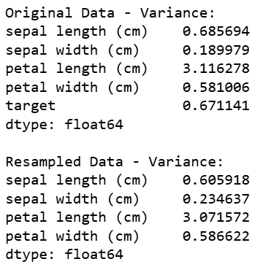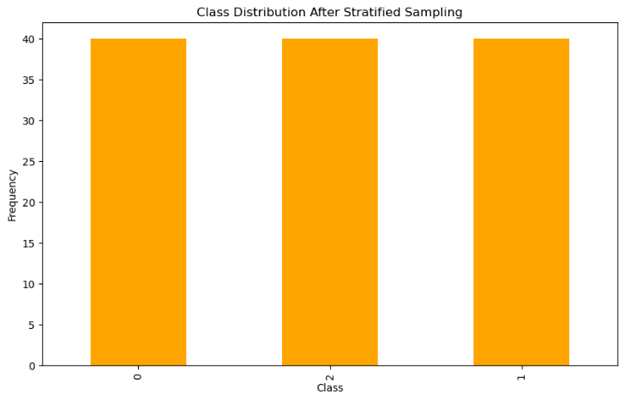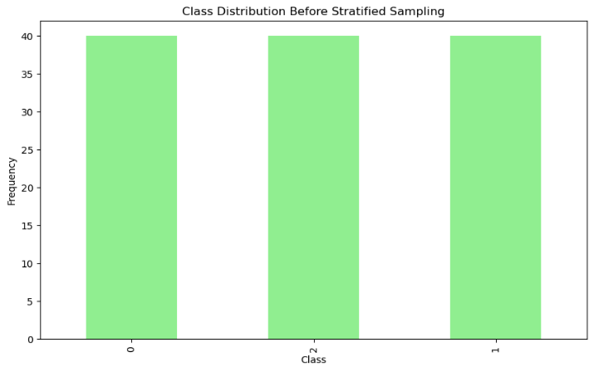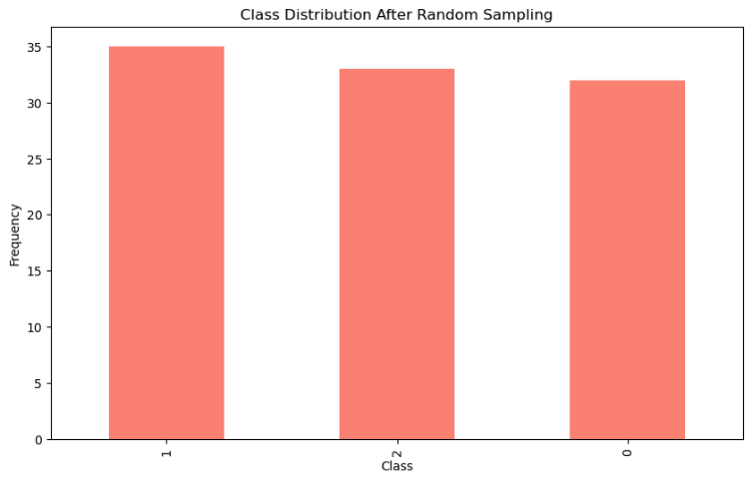

***Fig 6: Variance of the Dataset***

***Fig 5: Class Distribution after Stratified Sampling***

***Fig 4: Class Distribution before Stratified Sampling***

***Fig 3: Class Distribution after Random Sampling***

***Fig 1: Dataset Printing***

***Fig 2: Class Distribution before Random Sampling***